Seminar Report

On

New Approach to SCM (Supply Chain Management) using Blockchain .

By

Ayush Vedprakash Agarwal

**TCOA-02**

Under the guidance

Of

Prof. Latika Desai





**Department of Computer Engineering**

**Dr. D. Y. Patil Unitech Society’s**

**Dr. D. Y. Patil Institute of Technology**

**Sant Tukaram Nagar, Pimpri, Pune-18**

**Affiliated to Savitribai Phule Pune University, Pune**

**[2018-2019]**

Department of Computer

Engineering,

Dr. D. Y. Patil Institute of Technology, Pimpri, Pune.



**CERTIFICATE**

This is to certify that **Ayush Vedprakash Agarwal** from **Third Year Department of computer Engineering** has successfully completed his seminar work **titled “New Approach to SCM (Supply Chain Management) using blockchain”** at **Dr. D. Y. Patil Institute of Technology and Engineering, Pimpri** in the partial fulfillment of the Bachelor’s Degree in Engineering.

Prof. Latika Desai Head of the Department Principal

# Acknowledgement

I would like to express my deep gratitude to professor Latika Desai for their patient guidance, enthusiastic encouragement and useful critiques of this research work, Also for their advice and assistance in keeping my progress on schedule. I would also like to thanks all the authors, writers and technical experts whose Research papers, Books and Websites were used in order to fulfill my seminar report work.

# Table of Contents

|  |  |  |
| --- | --- | --- |
| **S.R no.** | **Description** | **Page no.** |
| 1 | Abstract and Keywords |  |
| 2 | Objectives |  |
| 3 | Introduction |  |
| 4 | Literature survey |  |
| 5 | Details of design |  |
| 6 | Technology |  |
| 7 | Analysis |  |
| 8 | Conclusions |  |
| 9 | References |  |
| 10 | Plagiarism Check report |  |
| 11 | Report Documentation |  |

# List of figures

|  |  |  |
| --- | --- | --- |
| **S.R.no** | **Description** | **Page no.** |
| 1 | Flow Diagram |  |
| 2 | Technology stack |  |
| 3 | Percentage of sales |  |

**List of Tables**

|  |  |  |
| --- | --- | --- |
| **S.R.no** | **Description** | **Page no.** |
| 1 | Technical Terms |  |
| 2 | Literature Survey |  |

# Abstract

The Blockchain technology is a relatively new approach in the field of information technologies. Blockchain is a recently introduced concept. Initially popularized by Bitcoin, Blockchain is more than the foundation of cypocurrency. It offers a secure way to exchange any kind of good, service, or transaction. Industrial growth increasingly depends on trusted partnerships, but increasing regulation, Cybercrime and fraud are inhibiting expansion. To address these challenges, Blockchain will enable more agile value chains, faster product innovations, closer customer relationships, and quicker integration with the IoT and cloud technology. Further Blockchain provides a lower cost of trade with a trusted contract monitored without intervention from third parties who may not add direct value. It facilitates smart contracts, engagements, and agreements with inherent, robust Cyber security features. We will take a closer look to how Blockchain can help solve many solutions in supply chain management like delay , counterfeit , etc.

## Keywords:

Blockchain, SCM, Bitcoin , Smart Contract, RFID, Token, Node.

# Objectives

* Study and understand Blockchain.
* Study how Blockchain can revolutionize the industry.
* Study current supply chain management tools.
* Take a closer look on how Blockchain can be used in supply chain management.

# Introduction

Wikipedia defines Blockchain as “A decentralized and distributed digital ledger that is used to record transactions across many computers so that the record cannot be altered retroactively without the alteration of all subsequent blocks and the collusion of the network.”

Blockchain is a distributed ledger which is immutable. In blockchain transactions are group together to form a block and the blocks are chained with one another in such a way that if someone radioactively tries to change any block he has to change all the subsequent block.

In 2008, Satoshi Nakamoto introduced Bitcoin by releasing the pape “Bitcoin: A Peer-to-Peer Electronic Cash System.”. Bitcoin is a peer-to-peer electronic cash payment system. It was the first implementation of blockchain.

Supply Chain Management is one of the areas where Blockchain can be used to solve real business problems due to lack of visibility or component information as the product moves in the supply chain. Supply Chain Management is a active management of supply chain activities to maximize customer value and achieve a competitive advantage. It involves series of key activities and processes if completed in efficient and timely manner will increase productivity and product will be delivered on time. Nearly all the company in the world use ERP (Enterprise Resource Planning). And supply chain management tools. Despite the huge investment in digital infrastructure, most company have little or limited visibility and insights about their product throughout supply chain.

The modern challenges that the companies face can easily be tackled using blockchain. Blockchain can provide more visibility, trust, better insights and cost reduction through the use of smart contact, oracles, cryptograph.

**Technical terms**

|  |  |
| --- | --- |
| TERM | DESCRIPTION |
| Decentralized | The system that stores data across the network. |
| Smart contract | Encode business rules and business logic into software which executes with transactions. |
| Oracle | Mechanism that connects smart contract to the real world. |
| Token | An ”IOU” that can be redeemed for goods or services at a specified data in the future. |
| Node | The device in the Blockchain system. |

TABLE 1. Technical terms

**Literature survey**

|  |  |  |  |  |  |
| --- | --- | --- | --- | --- | --- |
| **Sr No.** | **Name Of Author** | **Paper** | **Year** | **Applications** | **Reference Links** |
| 1 | S.Nakamoto | Bitcoin: A Peer-to-Peer Electronic Cash System, | Oct,2008. | cryptocurrency | <https://bitcoin.org/bitcoin.pdf> |
| 2 | IBM | THE SMARTER SUPPLY CHAIN OF THE FUTURE | 2017 | Trace drug in every stage of supply chain | <https://www-03.ibm.com/> |
| 3 | Aziz Muysinaliyev, Sherzod Aktamov | Supply chain management concepts: literature review | Jan. 2014 | SCM | <http://www.iosrjournals.org/iosr-jbm/papers/Vol15-issue6/I01566066.pdf> |

|  |  |  |  |  |  |
| --- | --- | --- | --- | --- | --- |
| **Sr No.** | **Name Of Author** | **Paper** | **Year** | **Applications** | **Reference Links** |
| 4 | Mayra Samaniego , Ralph Deters | Blockchain Based  Framework For Data Sharing | Dec. 2016 | IOT | <https://ieeexplore.ieee.org/document/7917130> |
| 5 | SHANGPING .W YINGLONG .Z, YALING ZHANG | Blockchain Framework For Data Sharing | 2018 | Secure Data Transfer | <https://ieeexplore.ieee.org/document/8292361> |
| 6 | Stefan Hickmott,  Chad Fernandez,  Alex Norta | Commercial Property Tokenizing With Smart  Contracts | 2018 | Real-Estate Market | <https://ieeexplore.ieee.org/document/8489534> |

TABLE 2. Literature Survey

**Design Details**

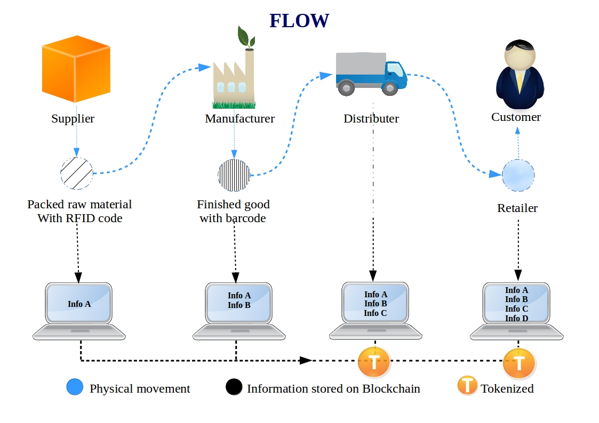Fig 1. Flow Diagram

Different nodes in the system would interact with the blockchain and enter the product detail at that particular time with the use of DApp (Distributed Application). Different IOT sensors or oracles will also capture the data such as humidity, temperature wherever required. The product ownership will be then transfer to different owners throughout the product journey this data will also be stored in the block through smart contract. Consider a sample life cycle of the product A. The Manufacturer order the raw material for the product A. The supplier than packs all the raw material needed along with a RFID code that the supplier will enter this detail in the blockchain and transport it to the manufacturer.

Manufacturer after receiving the product will confirm the package and enter the necessary details in blockchain. After the product have been Finished a unique number (QRcode, Barcode ,RFID code) would be assigned to the product and product would be tokenized to the Distributor. The distributer after the Transportation of the product will tokenize it to the retailer.

This system will establish a network of trust through shared ledger, because of neutral participants maintains a permissioned, distributed ledger with copies of authority approval status, full audit history, document filings, and relevant supply chain events, even a small change results in a new immutable block. Cryptography will enable permissioned access only to the participating parties in a particular transaction. All the documentation and authority approvals will be pre-programmed into the blockchain with the help of smart contracts. All filings and approvals of authority can only be changed if approved by the parties taking part in the shipment, This will create trust as full audit history is maintained on the Blockchain.

**Technology**

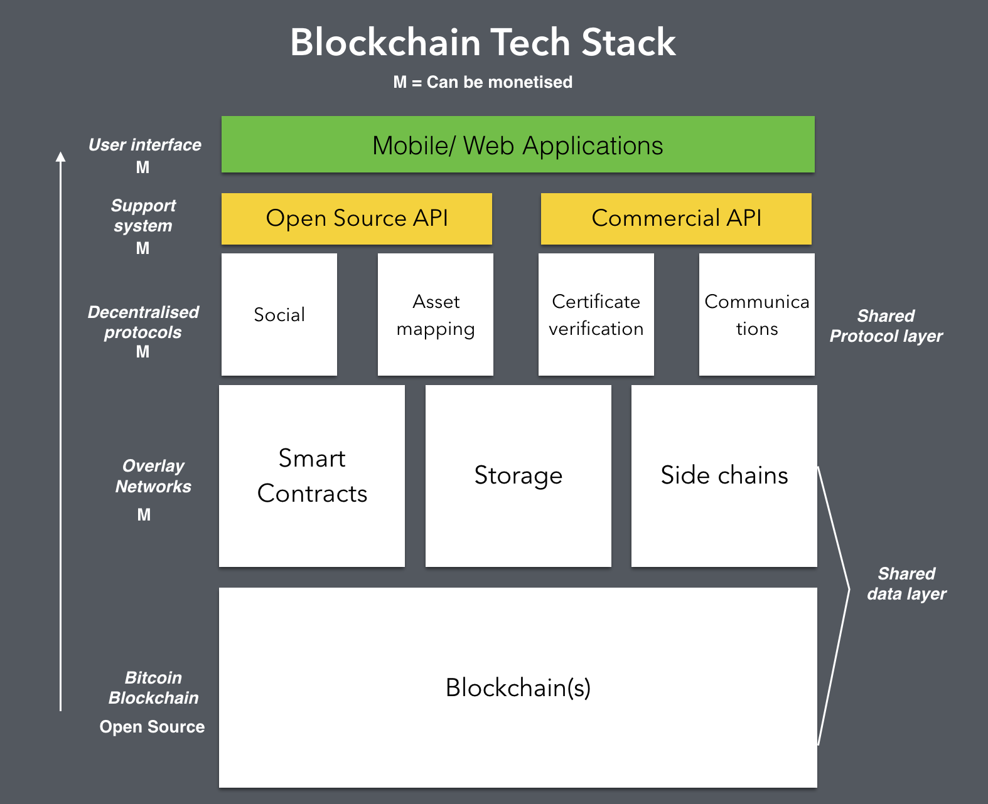Fig 2. Technology Stack

The above figure shows the technical details of the SCM (Supply chain management) using blockchain. As the system will show information about the transaction to the relevant parties the blockchain network would be permissioned blockchain and we can use the open source blockchain technology such as Hyperledger composer or Corda. We can communicate with other systems through API’s such as REST API. The DApp (Distributed Application) can be web based or Mobile application.

**Analysis**

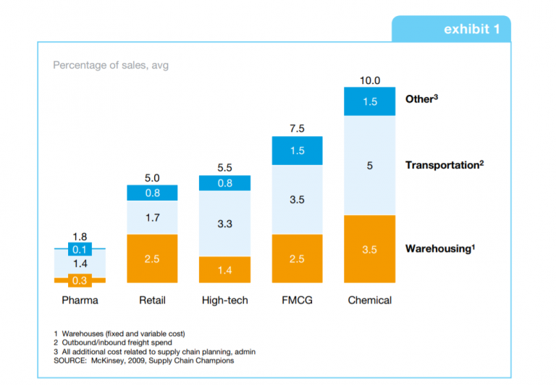Fig 3. Percentage of Sales

According to the survey done by McKinsey, “Lean and Mean – how does your supply chain shape up?”[9], Most of the cost and time of many supply chain lurks ignored and unmanaged in outbound logistics and behind the closed doors of distribution center. Upto 10% of overall cost of the product is due to supply chain costs, Companies can save 20-50% in warehousing and up to 40% in transportation if we can effectively manage the supply chain process.

**Conclusion**

Blockchain is a distributed digital ledger which is immutable. Blockchain build trust in trustless society with the help of technique such as smart contract, cryptography etc. Blockchain is an emerging technology with many application such as supply chain. Blockchain alone is not so effective if we combine it with outer technologies such as RFID, Machine Learning, IoT, etc. will greatly improve the Supply Chain Management process.

Complete transformation of supply chain will not happen in one day, But supply chains can start using blockchain for small portions of the operations. “Smart contracts” can play a crucial role to eliminate cost delays and waste currently because of all the paperwork handling done manually. Lastly, Business and brands need to embrace Blockchain technology well in time so that they can reap its reward and get better with time.

**References**

1. Vujicic, Dejan, et al. “Blockchain Technology, Bitcoin, and Ethereum: A Brief Overview.” *2018 17th International Symposium INFOTEH-JAHORINA (INFOTEH)*, 2018, doi:10.1109/infoteh.2018.8345547.
2. “What Is Bitcoin?” *CNNMoney*, Cable News Network, [money.cnn.com/infographic/technology/what-is-bitcoin/index.html.](http://money.cnn.com/infographic/technology/what-is-bitcoin/index.html.)
3. Tasatanattakool, Pinyaphat, and Chian Techapanupreeda. “Blockchain: Challenges and Applications.” *2018 International Conference on Information Networking (ICOIN)*, 2018, doi:10.1109/icoin.2018.8343163.
4. Miller, Dennis. “Blockchain and the Internet of Things in the Industrial Sector.” *IT Professional*, vol. 20, no. 3, 2018, pp. 15–18., doi:10.1109/mitp.2018.032501742.
5. “Lean and Mean-How Does Your Supply Chain Shape Up.” *Scribd*, Scribd, www.scribd.com/document/311191001/Lean-and-Mean-How-Does-Your-Supply-Chain-Shape-Up.
6. “How Blockchain Revolutionizes Supply Chain Management.” *Digitalist Magazine*, www.digitalistmag.com/finance/2017/08/23/how-the-blockchain-revolutionizes-supply-chain-management-05306209.
7. “Digitizing Global Trade with Maersk and IBM.” *Blockchain Pulse: IBM Blockchain Blog*, 19 Sept. 2018, [www.ibm.com/blogs/blockchain/2018/01/digitizing-global-trade-maersk-ibm/](http://www.ibm.com/blogs/blockchain/2018/01/digitizing-global-trade-maersk-ibm/)
8. “Chain Business Insights Survey Indicates Blockchain Adoption for Supply Chains.” *Allcoinsnews.com*, 29 May 2017, allcoinsnews.com/2017/05/29/chain-business-insights-survey-indicates-blockchain-adoption-for-supply-chains/.
9. “Blockchain.” *Wikipedia*, Wikimedia Foundation, 14 Mar. 2019, en.wikipedia.org/wiki/Blockchain#cite_note-te20151031-1.
10. Wikipedia , “Blockchain”, <https://en.wikipedia.org/wiki/Blockchain#cite_note-te20151031-1>
11. Bastin, Jacek, et al. “Blockchain In: The Supply Chain Industry.” *BitShouts*, 15 Mar. 2019, bitshouts.com/blockchain-supply-chain/.
12. Ahram, Tareq, et al. “Blockchain Technology Innovations.” *2017 IEEE Technology & Engineering Management Conference (TEMSCON)*, 2017, doi:10.1109/temscon.2017.799836
13. Wikipedia“Bitcoin”,<https://en.wikipedia.org/wiki/Bitcoin.>
14. Aziz Muysinaliyev, Sherzod Aktamov , “Supply chain management concepts: literature review” , [www.iosrjournals.org](http://www.iosrjournals.org/) , Jan. 2014 .
15. Nakamoto S., 2012. “Bitcoin: A peer-to-peer electronic cash system”, Oct,2008.
16. Morgen Peck , “REINFORCING THE LINKS OF THE BLOCKCHAIN”,IEEE Future Directions BLOCKCHAIN Initiative WHITE PAPER BLOCKCHAININCUBATOR.IEEE.ORG, November 2017 .

**Plagiarism check report**

|  |  |
| --- | --- |
| **Seminar Report Documentation** | |
| **Report Code:**TE-CS-Seminar 2018-2019 | **Report No:**TCOA-02 |
| **Report Title:** New Approach to SCM (Supply Chain Management) using Blockchain | |
| **Address:**Dr. D. Y. Patil Institute of Technology, Sant Tukaram Nagar, Pimpri, Pune, Pin-411018, M.S.India. | |
| **Address:** Sant Tukaram Nagar,Pimpri, Pune-411018.  **E-mail:**[ayushbansal323@gmail.com](mailto:tanujabedse1998@gmail.com)  **Cell-no:** 7776075075 | |
| **Year:** 2018-2019  **Branch:** Computer Engineering | |
| |  |  |  |  |  | | --- | --- | --- | --- | --- | | **Type of Report:**  Final | **Report checked by:** | **Report checked**  **Date:** | **Guide’s complete**  **Name:**  Prof. Latika Desai | **Total copies:**  2 |   **Keywords:** Blockchain, SCM, Bitcoin , Smart Contract, RFID, Token, Node. | |